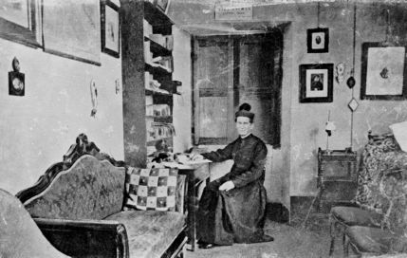

IV. EVANGELICAL POVERTY

Guideline 12: Processes required for change.

Let each community:

- Ensure that confreres know and put into practice what is indicated in the Provincial Directory’s poverty and administration section, especially in reference to personal use of good and technological tools.

- Diligently make the annual scrutinium paupertatis in view of a more credible witness.

- Prepare the annual budget, present the financial statement, regularly inform confreres of the financial situation and sensitise them to the cost of living; punctually hand over to the province any monies left over.

Guideline 13: Solidarity with the poor.

Let each community:

- Express its solidarity with the poor not only through ‘charity’, but also through choices that have an impact on the tenor of our lives.

- Educate, in collaboration with the educative and pastoral community, to a culture of solidarity, helping young people to bring a critical spirit to their interpretation of the economic and social phenomena of our time, involving them in initiatives and projects of development, and encouraging their taking part in similarly ordered activities of solidarity.

- Educate to a respect for ethnic and religious difference and encourage a spirit of brotherly concern.

Guideline 14: Responsible management of resources in a spirit of solidarity.

Let each community:

- Periodically assess the objectives and strategies of the work to avoid it being simply a business venture rather than a service of education and evangelization.

- Ensure that the financial transactions of all sectors of the work are referred to the administrative officer, the inventory is kept up to date, and that all necessary information is made available to assist the administrative personnel in carrying out their work.

- Guarantee good planning and management with regard to personnel we employ, respecting the rights and duties laid down in law and seeing that they are respected.

- Be responsible for the planning, execution and monitoring of building and maintenance works, in understanding with the Provincial Economer.

- Study its own financial situation to ensure the sustainability of the work and, if dependent on external help, set up a plan for financial self-sufficiency.

- Give attention to the correct use of funds which come from other bodies or institutions.

- Respect the intentions of benefactors.

